**Creating Microservices for account and loan**

**For Account**

package com.cognizant.account.controller;

import java.util.HashMap;

import java.util.Map;

import org.springframework.web.bind.annotation.GetMapping;

import org.springframework.web.bind.annotation.PathVariable;

import org.springframework.web.bind.annotation.RequestMapping;

import org.springframework.web.bind.annotation.RestController;

@RestController

@RequestMapping("/accounts")

public class AccountController {

@GetMapping("/{number}")

public Map<String, Object> getAccountDetails(@PathVariable String number) {

Map<String, Object> response = new HashMap<>();

response.put("number", number);

response.put("type", "savings");

response.put("balance", 234343);

return response;

}

}

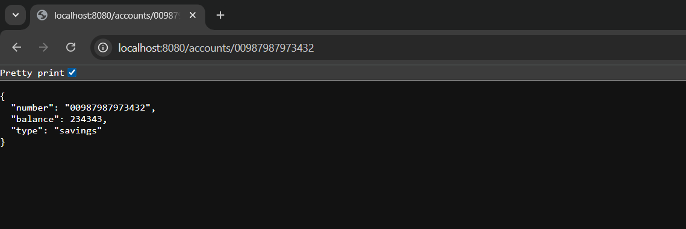

**For Loan**

package com.cognizant.loan.controller;

import java.util.HashMap;

import java.util.Map;

import org.springframework.web.bind.annotation.GetMapping;

import org.springframework.web.bind.annotation.PathVariable;

import org.springframework.web.bind.annotation.RequestMapping;

import org.springframework.web.bind.annotation.RestController;

@RestController

@RequestMapping("/loans")

public class LoanController {

@GetMapping("/{number}")

public Map<String, Object> getLoanDetails(@PathVariable String number) {

Map<String, Object> response = new HashMap<>();

response.put("number", number);

response.put("type", "car");

response.put("loan", 400000);

response.put("emi", 3258);

response.put("tenure", 18);

return response;

}

}

